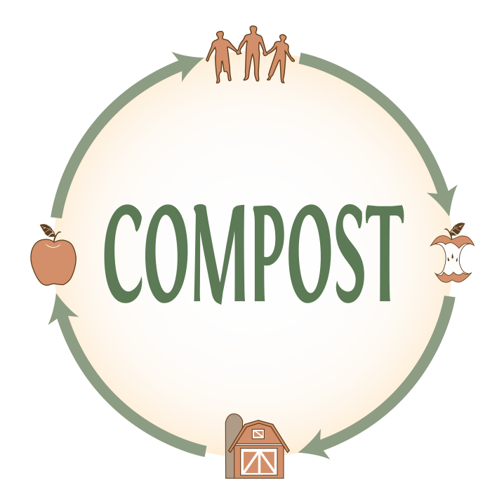  Kitchen Harvest Compost Collection Service  ~ Collects your kitchen and yard waste  ~ Supports local farming  ~ Grows local organic food  ~ Delivers discounted soil, seedlings & organic food to your home  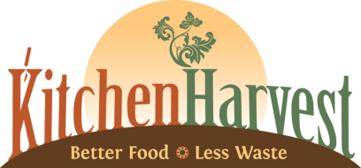  Start your subscription today at: MyKitchenHarvest.com | Kitchen Harvest Compost Collection Service  ~ Collects your kitchen and yard waste  ~ Supports local farming  ~ Grows local organic food  ~ Delivers discounted soil, seedlings & organic food to your home  Start your subscription today at: MyKitchenHarvest.com | Kitchen Harvest Compost Collection Service  ~ Collects your kitchen and yard waste  ~ Supports local farming  ~ Grows local organic food  ~ Delivers discounted soil, seedlings & organic food to your home  Start your subscription today at: MyKitchenHarvest.com
Why Compost?  1. Soil Health: No fertility, no food. Effectively composting returns nutrients to the soil, fosters healthy bio-diversity, reduces the need for synthetic fertilizers and pesticides, and allows life to flourish.  2. Fossil Fuels: Relying on a more local, natural system of waste reduction and food production decreases our reliance on fossil fuels, a costly resource.  3. Water: Soil rich with organic matter retains water better, and erodes less. Incorporating compost into our soils reduces the need for irrigation and helps preserve water, arguably our most precious resource.  4. Climate Change: The U.S. alone wastes some 35 million tons of food in landfills every year - enough to fill 5 Citizens Bank Parks to the brim. Picture that. In a landfill or stagnant backyard pile where compostables are starved of light and air, they decay anaerobically (without oxygen) producing methane. Methane is a greenhouse gas with 25 times the global warming potential of carbon dioxide.  5. Our Health: Local seasonal ingredients harvested at their peak nutritional value from healthier soils means healthier food with fewer "food miles." We eat better, exercise more, and spend more time together as a family or community when we graze from our gardens and local farms rather than driving to the store.  It just makes sense.  – Chris Pieretti, owner, Kitchen Harvest, Inc.  MyKitchenHarvest.com | Why Compost?  1. Soil Health: No fertility, no food. Effectively composting returns nutrients to the soil, fosters healthy bio-diversity, reduces the need for synthetic fertilizers and pesticides, and allows life to flourish.  2. Fossil Fuels: Relying on a more local, natural system of waste reduction and food production decreases our reliance on fossil fuels, a costly resource.  3. Water: Soil rich with organic matter retains water better, and erodes less. Incorporating compost into our soils reduces the need for irrigation and helps preserve water, arguably our most precious resource.  4. Climate Change: The U.S. alone wastes some 35 million tons of food in landfills every year - enough to fill 5 Citizens Bank Parks to the brim. Picture that. In a landfill or stagnant backyard pile where compostables are starved of light and air, they decay anaerobically (without oxygen) producing methane. Methane is a greenhouse gas with 25 times the global warming potential of carbon dioxide.  5. Our Health: Local seasonal ingredients harvested at their peak nutritional value from healthier soils means healthier food with fewer "food miles." We eat better, exercise more, and spend more time together as a family or community when we graze from our gardens and local farms rather than driving to the store.  It just makes sense.  – Chris Pieretti, owner, Kitchen Harvest, Inc.  MyKitchenHarvest.com | Why Compost?  1. Soil Health: No fertility, no food. Effectively composting returns nutrients to the soil, fosters healthy bio-diversity, reduces the need for synthetic fertilizers and pesticides, and allows life to flourish.  2. Fossil Fuels: Relying on a more local, natural system of waste reduction and food production decreases our reliance on fossil fuels, a costly resource.  3. Water: Soil rich with organic matter retains water better, and erodes less. Incorporating compost into our soils reduces the need for irrigation and helps preserve water, arguably our most precious resource.  4. Climate Change: The U.S. alone wastes some 35 million tons of food in landfills every year - enough to fill 5 Citizens Bank Parks to the brim. Picture that. In a landfill or stagnant backyard pile where compostables are starved of light and air, they decay anaerobically (without oxygen) producing methane. Methane is a greenhouse gas with 25 times the global warming potential of carbon dioxide.  5. Our Health: Local seasonal ingredients harvested at their peak nutritional value from healthier soils means healthier food with fewer "food miles." We eat better, exercise more, and spend more time together as a family or community when we graze from our gardens and local farms rather than driving to the store.  It just makes sense.  – Chris Pieretti, owner, Kitchen Harvest, Inc.  MyKitchenHarvest.com

