Township Tree Talk

Shade Tree Commission Newsletter

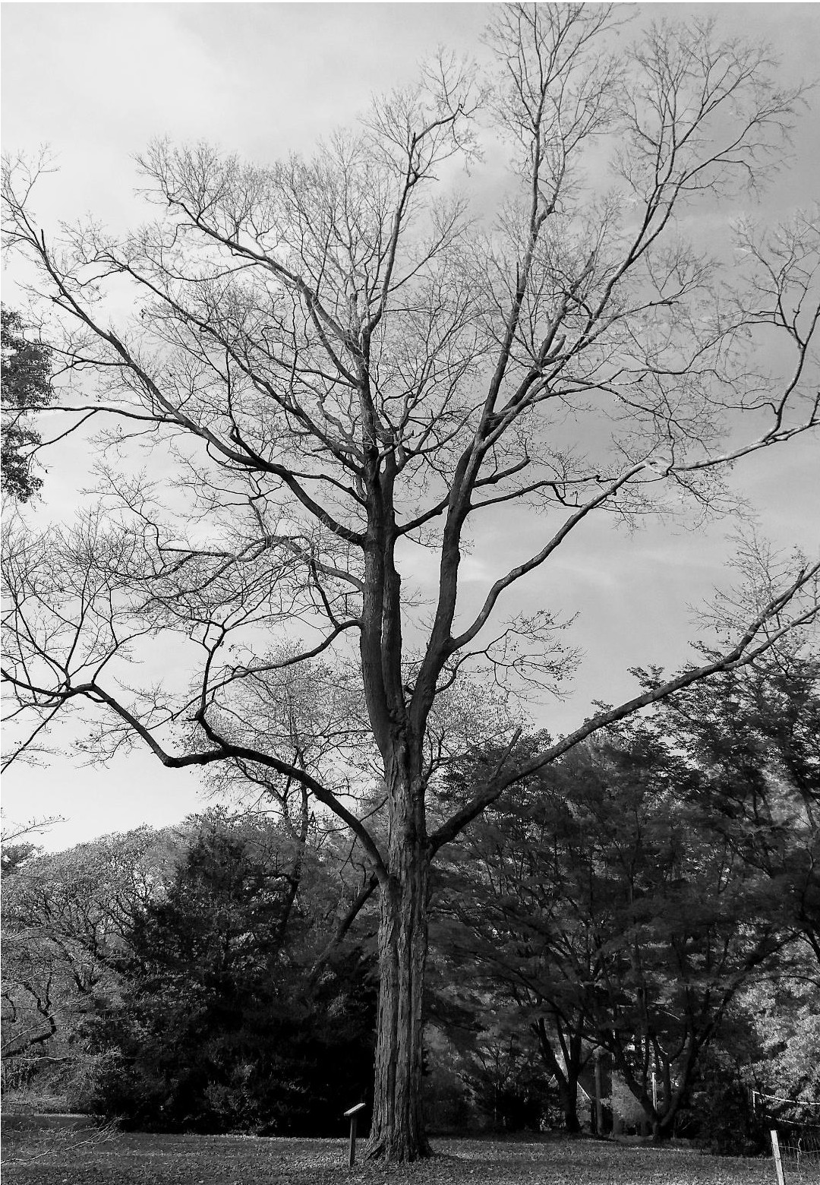
Trees Planted in Nether Providence Parks
On November 18, the Shade Tree Commission (STC) together with Nether Providence Township Employees and Boy Scout Pack 145, planted a total of eight trees at Summit School, Sapovits Park, Wilson Park, and Bullens Lane Park. The new trees included two service berries, two red maples, two sugar maples, one red oak, and one American elm.

The trees were purchased as part of the Pennsylvania Horticulture Society's Plant a Million Program. The PHS sells bare root saplings to organizations in thirteen counties surrounding Philadelphia with the goal of planting one million trees and increasing our tree cover. Our Township has participated in this program for several years and has planted a several dozen trees throughout Nether Providence. As in years past, our excellent Public Works Department will water and care for the new trees as they establish themselves over the next year. We hope you will stop by and welcome our new neighborhood trees.

Join the Shade Tree Commission
The Shade Tree Commission is currently seeking passionate individuals to serve as ad-hoc members. Anyone interested is encouraged to apply. Please send an email to Gary Cummings (gcummings@netherprovidence.org) if you are interested.

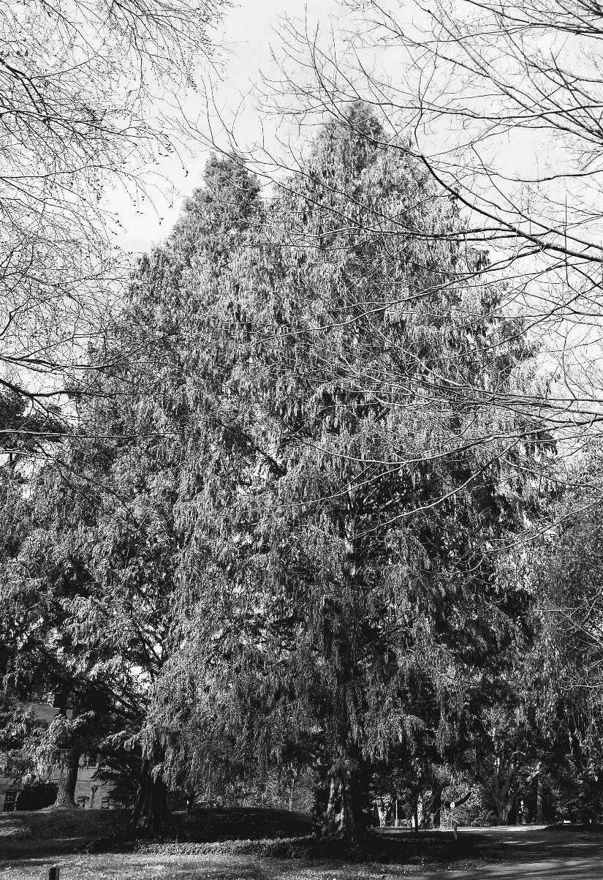
Register Your Heritage Tree
In 2018, the STC continues documenting of Nether Providence Township's exceptional trees. Heritage trees have historic distinction, are of an unusual species or have attained great height or girth. These trees give our community its unique beauty and character.

This year, members of the STC would like to compile a broader list of large and unusual trees in the township. The STC invite homeowners to share the location of special trees on their properties. A member of the STC will visit the property to document the species, size, and GPS location of each tree. Homeowners with unique trees will be invited to apply for township Heritage Tree status. Information about all trees will become part of the Shade Tree Commission's database of trees, providing the STC a clearer understanding of township tree cover, species distribution, and neighborhood landscape.

Please complete the attached form and deliver it to the Nether Providence Township Building to learn more about your property's beautiful trees.
Dawn Redwoods at Pendle Hill

YES! I would like the Shade Tree Commission to document my tree.

Name:___________________________________________________ Phone Number: _____________________________
Address: ____________________________________________________________________________________________
City: __________________________________________________________State:____________________Zip:_________
Email:______________________________________________________________________________________________
Species of Tree (if known):_____________________________________________________________________________
Location of Tree on Property: __________________________________________________________________________
Reason for Survey: ___ Size ___ Unusual Species ___ Historic Significance ____ Other: __________________________

Please return this form to:
Shade Tree Commission, Nether Providence Township Building, 214 Sykes Land, Wallingford, PA 19086

Or email Lisa Jacobs at nptstc@gmail.com.

