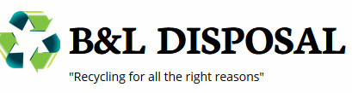

27 September, 2017

Today we were informed that BAGGED RECYCLE MATERIAL will no longer be acceptable at the Recycle Facility. This means ALL recycle material will have to be placed in a recycle container in order for us to pick it up. This policy is already in place, so we need to inform residents immediately.

Thank you for your help and co-operation in this matter.

Should you have any questions please feel free to contact our office at 484-326-9774 at your convenience. And as always we appreciate the opportunity to work with you to provide your Municipal Waste and Recycle services.

Sincerely

Mike McArdle
B+L Disposal

