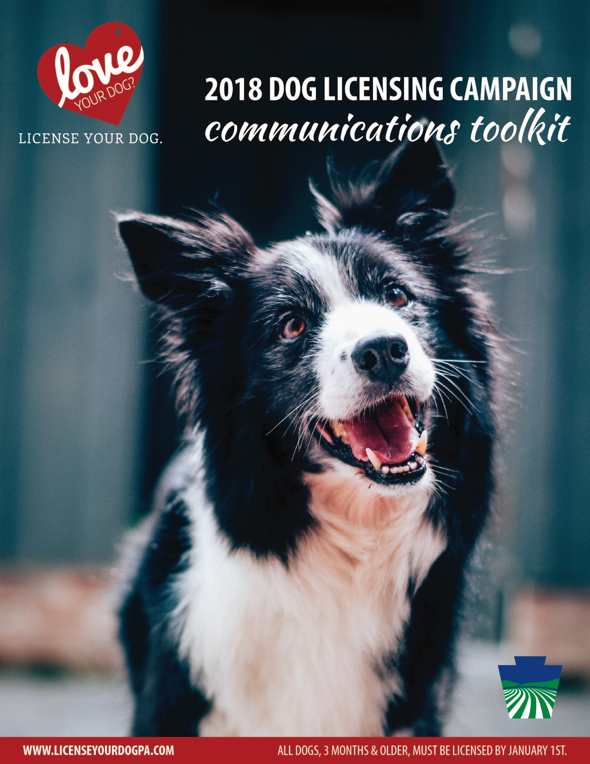

Table of Contents:
Introduction to Pennsylvania Dog Licensing
Suggested Twitter and Facebook posts
Sample Content for e-Newsletters and Websites
Sample Press Release template

Introduction
Bureau of Dog Law Enforcement

The Bureau of Dog Law Enforcement is responsible for ensuring the welfare of dogs and puppies in licensed kennels. The Bureau also regulates activities pertaining to dogs that are classified as dangerous, and oversees annual licensure and rabies vaccinations for dogs.

Our state dog wardens:
  - Enforce licensing and rabies laws
  - Seize and detain any dog viewed running at large without its owner
  - Investigate dog bites and establish and enforce quarantine of dogs
  - Enforce kennel licensing and regulations through at least two inspections each year of every licensed kennel
  - Maintain a registry of dogs declared dangerous by a magisterial district judge and perform dangerous dog inspections
  - Prosecute dog law violations in court
  - Provide educational services about dog ownership

Pennsylvania’s Rabies Law:
Ignoring Pennsylvania’s rabies vaccination law can be costly – in more ways than one. Dogs and cats are exposed to the rabies virus through wild and stray animals, posing a threat to their health and yours.
  - Dogs and cats three months or older must have a current rabies vaccination
  - Owners of non-vaccinated pets may be fined up to $300 plus court costs
  - Licensed veterinarians can vaccinate dogs and provide a vaccination certificate
  - Dog wardens perform random checks to ensure rabies vaccinations are current

License Your Dog. It’s the Law:
- All dogs three months or older must be licensed by Jan. 1 of each year
- Owners of non-licensed dogs can be cited with a maximum fine of $300 per dog plus court costs
- Dog wardens randomly canvass neighborhoods to ensure all dogs are licensed, violators may be fined
- If your dog gets lost, a current license is the fastest way to get your dog back home
- Licensing fees help the millions of dogs in Pennsylvania by funding the Bureau of Dog Law Enforcement
- Purchase a license from your local county treasurer or issuing agent
- An annual license is $8.50 and a lifetime license is $51.50, if your dog is spayed or neutered, the annual fee is $6.50 and lifetime is $31.50, discounts are available to older adults and people with disabilities

Pennsylvania’s Dog Laws:
- If your dog is not licensed, you may be fined up to $300 per dog. Get a license at your county treasurer’s office.
- Your dog must be under control and supervised at all times. You are responsible for any damages caused by your dog on someone else’s property.
- It is illegal to mistreat or abuse animals. Report suspected abuse to your local humane organization or police.
- Purposely poisoning a dog, whether it is yours or someone else’s, is illegal.
- You may not abandon or attempt to abandon any dog. You could be fined $1,000 plus court costs.
- Puppies under eight weeks old cannot be bartered, traded, sold, or transferred.
- You must have a kennel license if you keep, sell, transfer, adopt or foster at least 26 dogs in a calendar year.
- If your dog attacks or kills a human or domestic animal without provocation, it may be considered dangerous. You may face extensive fines and restrictions.

Social Media
Tweets and Facebook posts are great ways to raise public awareness about dog licensing and the campaign for 2018. All posts related to dog licensing should use the hashtag #LoveYourDogLicenseYourDog

We’ve created some suggested posts for you to share on your pages as you see fit. You may also follow us on Twitter (@PAAgriculture) or like us on Facebook (fb.com/PADeptofAg) and share our posts promoting the campaign.

Twitter Suggestions: (images for actual use on social are attached separately)
A dog license dramatically increases your chances of getting them back if they go missing. (Insert your method for acquiring a dog license here – online, mail-in form, come to the office, etc.) #LoveYourDogLicenseYourDog

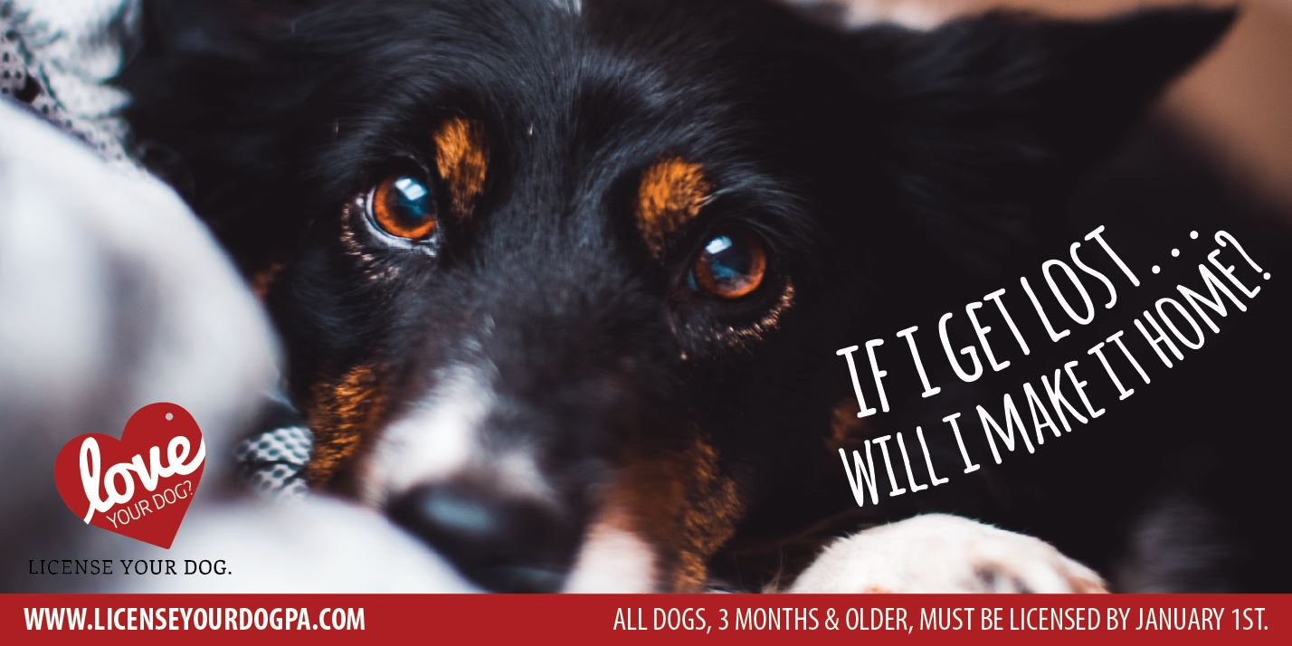

Your pups are patiently waiting! All dogs, 3 months & older, must be licensed by January 1. (Insert your method for acquiring a dog license here) #LoveYourDogLicenseYourDog

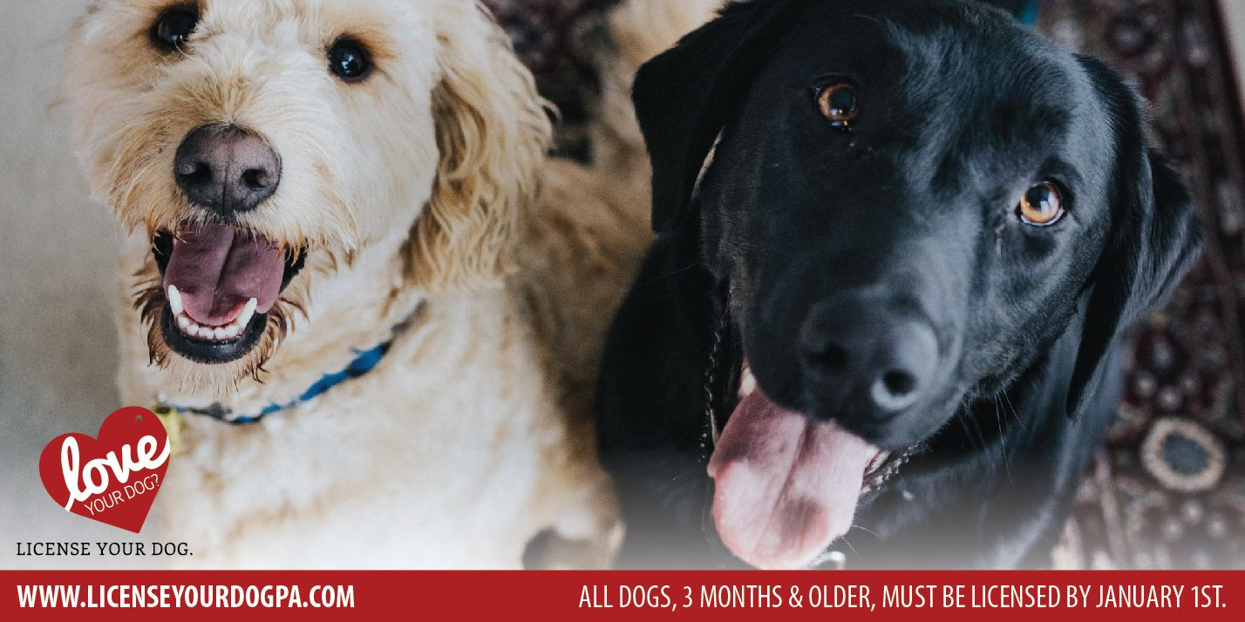

Time is running out! Get your dog licensed before January 1. (Insert your method for acquiring a dog license here – online, mail-in form, come to the office, etc.)
#LoveYourDogLicenseYourDog

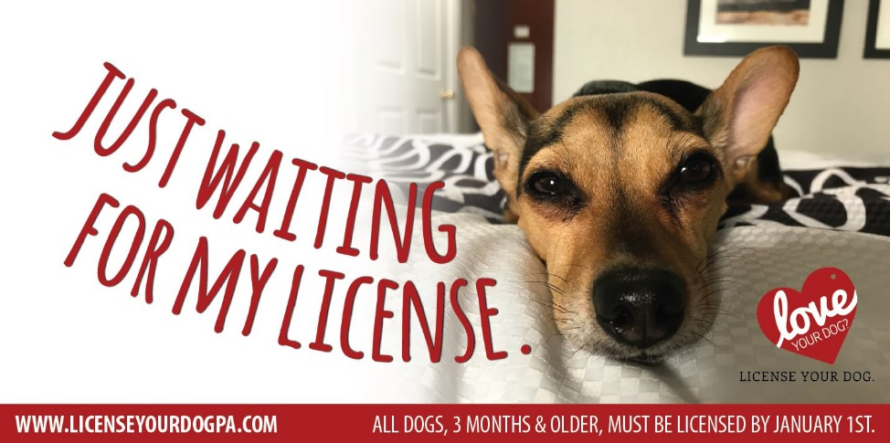

Generic Tweets:
We’ve got your 2018 dog licenses! Stop in and purchase your license today! #LoveYourDogLicenseYourDog

Your dog is a member of the family, give them the gift that keeps on giving – 2018 licenses now on sale! #LoveYourDogLicenseYourDog

#DYK that a dog license is the fastest way to bring your dog home, should they ever get lost? 2018 licenses now available! #LoveYourDogLicenseYourDog

A small action with a big impact – purchase your 2018 dog license today, keep your dog safe #LoveYourDogLicenseYourDog

Images to accompany generic tweets:
(images for actual use on social media are attached separately)

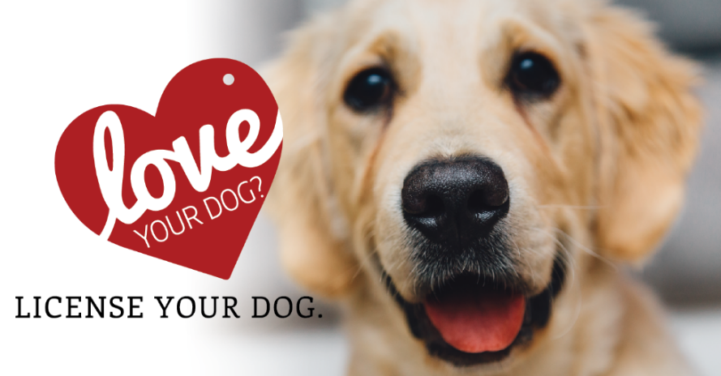

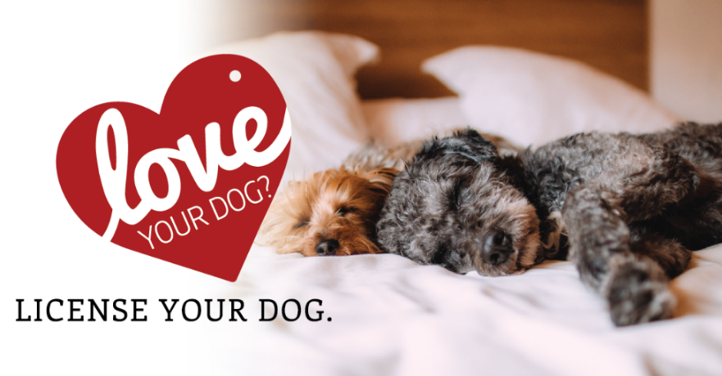

Facebook: (images for actual use on social are attached separately)
Set your dog’s mind, and your own, at ease. Licensing your dog dramatically increases your chances of getting them back if they go missing. 2018 dog licenses are now available! All dogs, three months and older, must be licensed by January 1, 2018. #LoveYourDogLicenseYourDog
(Insert your method for acquiring a dog license here – online, mail-in form, come to the office, etc.)

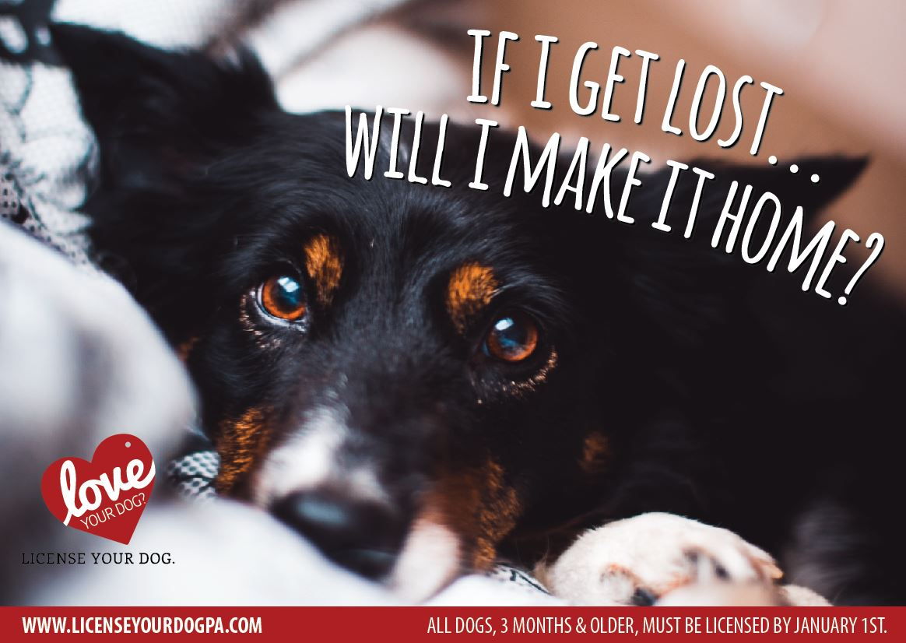

The time has come! 2018 dog licenses are now available, and your pups are patiently waiting! All dogs, three months and older, must be licensed by January 1, 2018. #LoveYourDogLicenseYourDog
(Insert your method for acquiring a dog license here – online, mail-in form, come to the office, etc.)

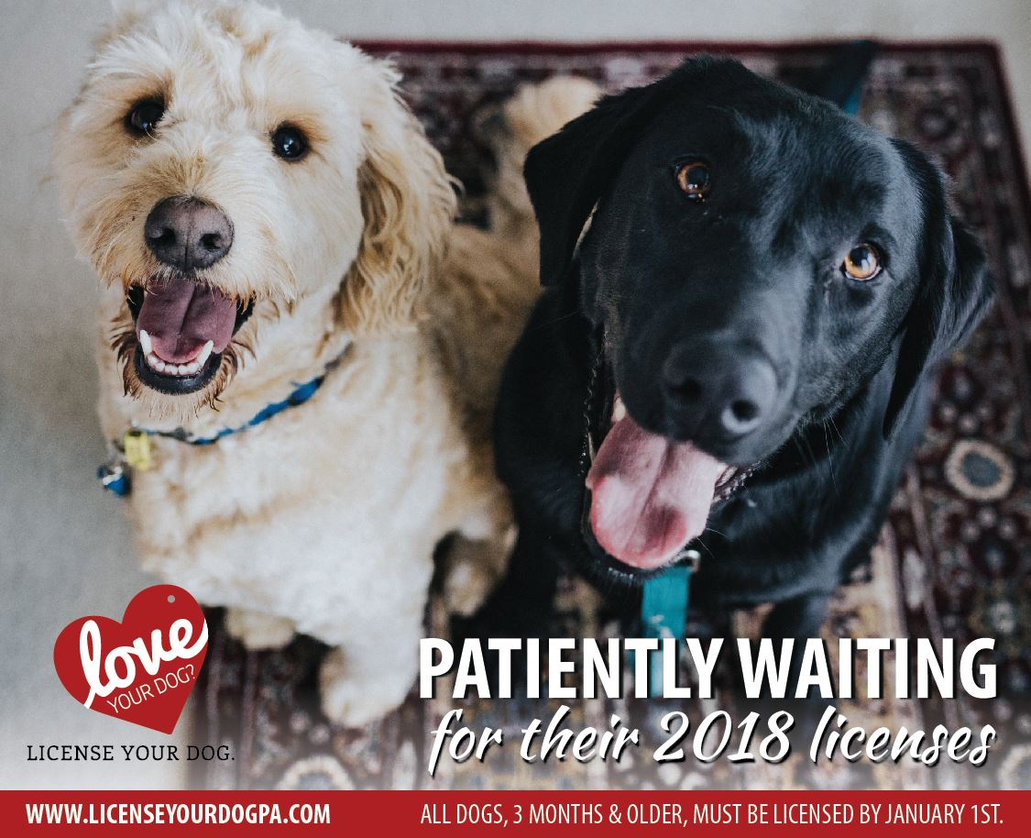

Time is running out! All dogs, three months and older, must be licensed by January 1, 2018. Why?
1⃣ It’s the fastest way to get your lost dog returned safely home.
2⃣ It allows the Bureau of Dog Law to protect the dogs of PA.
3⃣ And, it’s the law.
#LoveYourDogLicenseYourDog
(Insert your method for acquiring a dog license here – online, mail-in form, come to the office, etc.)

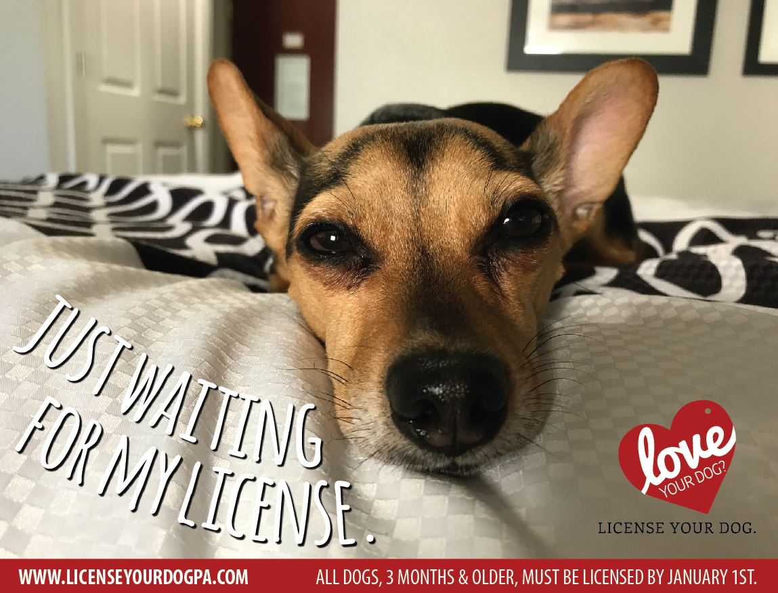

Sample Content for Newsletters and Websites
License Your Dog in PA
All dogs three months or older must be licensed by Jan. 1 of each year. Violators can be cited with a maximum fine of $300 per violation plus court costs.
An annual license is $8.50 and a lifetime license is $51.50. If the animal is spayed or neutered, the annual fee is $6.50 and lifetime is $31.50. Discounts are available to older adults and people with disabilities.
The small license fee helps the millions of dogs in the state by funding the Pennsylvania Department of Agriculture Bureau of Dog Law Enforcement.
Dog licenses are available from your local county treasurer and other licensing agents.
Reasons for dog licensing:
- It’s the law. All dogs three months and older must have a current license.
- If your dog gets lost, a license is the best way to get him back. A license helps animal control and shelters identify your dog and get him back home safely.
- The cost of a license is less than the penalty for being caught without one. Owners who fail to license their dogs could face a fine of up to $300 for each unlicensed dog.
- License fees support animal control. The annual fee you pay to license your dog helps keep shelters running and supports the work of the Bureau of Dog Law Enforcement, which is responsible for ensuring the welfare of dogs, regulating dangerous dogs and overseeing annual licensing and rabies vaccinations.

Sample News Release
FOR IMMEDIATE RELEASE
Month 00, 2017
2018 Dog Licenses Available at County Treasurers’ Offices; All Dogs Must be Licensed by Jan. 1
<<CITY>>, PA – Pennsylvanians can now purchase 2018 dog licenses from their county treasurers. State law requires all dogs three months and older to be licensed by Jan. 1 of each year.
Insert a quote from the county treasurer.
An annual dog license is $8.50, or $6.50 if the animal is spayed or neutered. Lifetime licenses are available for dogs that have permanent identification like a microchip or tattoo. Older adults and people with disabilities may be eligible for discounts.
The dog license application is simple and only requests owner contact information and details about the dog being licensed, including name, age, breed and color.
[Insert name of county treasurer] offered these reasons for dog licensing:
- If a dog gets lost, a license is the best way to get him/her back. A license helps animal control and shelters identify a dog and its rightful owners.
- It’s the law. All dogs three months and older must have a current license.
- The cost of a license is less than the penalty for being caught without one. Owners who fail to license their dogs could face a fine of up to $300 for each unlicensed dog.
- License fees support animal control. The annual fee to license a dog helps keep shelters running and supports the work of the Pennsylvania Department of Agriculture’s Bureau of Dog Law Enforcement, which provides a number of vital services to protect dogs and the public. Last year, the Bureau of Dog Law Enforcement:
  - Enforced health and safety regulations in kennels by licensing 2,340 such operations and conducting more than 5,000 inspections.
  - Helped to secure 5,000 stray dogs, placing them in shelters until those that were licensed could be reunited with their owners.
  - Issued nearly 3,000 citations and filed 124 misdemeanor complaints for violations of the Dog Law, including failing to license dogs, abandoning dogs, and allowing them to run at large.
  - Investigated 955 dog bites, and they investigated and monitored 520 dogs that were deemed dangerous by magisterial judges.

For more information, contact <<INSERT COUNTY NAME>> County Treasurer <<INSERT TREASURER’S NAME>> at <<INSERT PHONE NUMBER AND/OR EMAIL ADDRESS>>. For a list of county treasurers, visit www.licenseyourdogPA.com or call the Department of Agriculture’s Bureau of Dog Law Enforcement Office at 717-787-3062.
MEDIA CONTACT: [Contact person for the county treasurer’s office]

